WINTER 2022
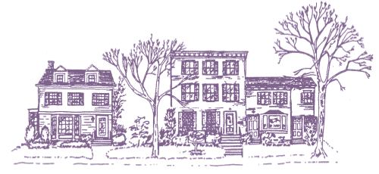

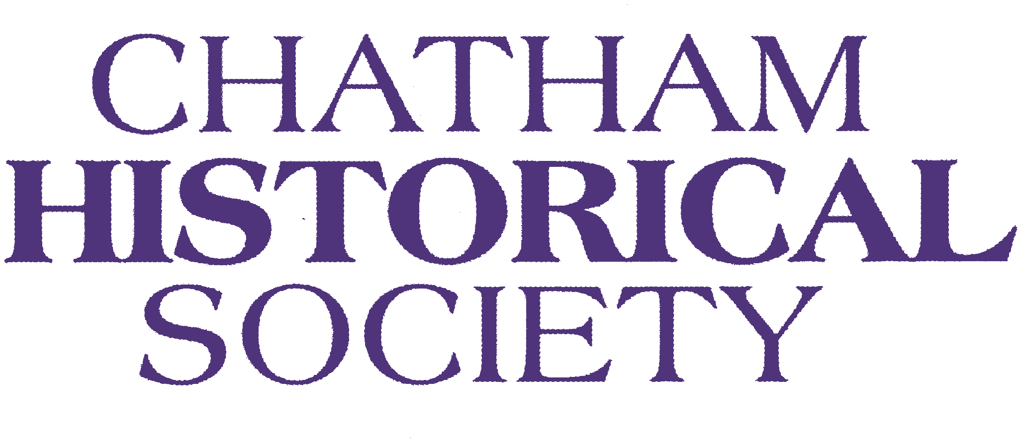

N E W S L E T T E R
HAPPY NEW YEAR!
by Karen Hoerrner and Deb Fabian
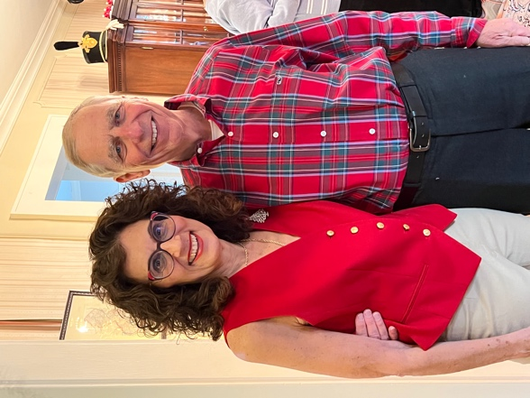
Photo: Our gracious hosts, Karen and Joel Boroff
We are excited to be coming together as a community to reconnect and share our passion for Chatham’s rich history. The Society had a wonderfully successful Holiday party on a beautiful Sunday afternoon on December 4th. The party, hosted by Karen and Joel Boroff was the perfect setting. Their home circa 1920 has been updated and was beautifully decorated. Approximately 40 people gathered including board members for delicious food and libations. See the recipe below for a truly unique cookie that was the talk of the party, marbled tahini cookie.
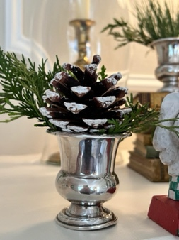
The Holiday party is one of the benefits of being a member of the Chatham Historical Society. During the pandemic, we gifted members a bottle opener created by ECLC students in 2021 and in 2020 we took one of iconic photos from our archives and had artist, Ingrid Hoerrner, enhance the skating scene with colorful accessories to create a unique ornament. We are pleased to be back together to share our love our town and community!
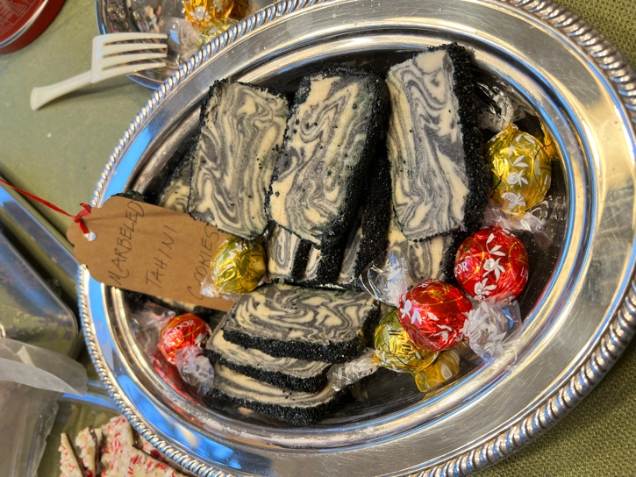
Marbled Tahini Cookies
Ingredients:
3 c flour
1 ½ t kosher salt
½ t baking powder
1 c unsalted butter
1 c unsifted confectioner sugar
1 large egg, room temperature
1 egg white
1 t vanilla extract
1/4 c plain tahini
3 T black tahini
Preparation:
In a medium bowl, whisk flour, salt, baking powder, set aside. Coat a small loaf pan with cooking spray then line with plastic wrap, tucking in the corners and leaving plenty of overhang. Set aside.
In the bowl of a stand mixer with the paddle attachment, cream the butter and confectioner’s sugar on medium speed until fluffy, 2 to 3 minutes, scraping bowl as needed. Add the large egg and the vanilla, beat until combined, about 2 minutes, scraping bowl as needed.
Add flour mixture, beat on low, then increase speed to medium and beat until dough starts to clump together, scraping bowl as needed.
Remove dough from bowl, knead lightly and form into a fat log. Cut into 2 pieces, one 1/3 of the log and the other 2/3s of the log. Return the larger piece to the bowl, add the plain tahini, and beat on medium speed to combine. Add the smaller piece and the black tahini to the bowl and beat on medium until fully combined.
On a generously floured surface, cut the white dough in half. Pat half of the black dough on top of the flattened white dough to match dimensions. Repeat with remaining white dough, then black dough, so you have four alternating layers of white and black dough. Cut in half crosswise, and gently knead and roll one piece to marble the two colors together. Repeat with the second piece of dough. Stack together (they should be fairly soft at this point, so be gentle), and briefly knead the pieces together to form one dough.
Press dough into prepared pan, and fold the plastic wrap over the top to seal. Gently press down to even out the surface as much as possible. Chill until firm, preferably overnight, or at least a few hours and up to 3 days ahead.
Heat oven to 325 degrees. Beat the egg white with 1 t water to thin it out. Spread the sanding sugar out on a small baking sheet. Remove the block of dough from the loaf pan and unwrap it. Trim the slanted sides and the top if you want them really square. Very lightly brush the outside of the block with the egg mixture. Press the block firmly to coat all sides (except the ends) with the sugar, sprinkling and pressing it on to cover any bare spots.
Cut the block into barely ¼ in thick slices, then lay them out 1 in apart on two parchment or silicone lined baking sheets. Freeze until firm, about 10 minutes.
Bake until cookies are golden underneath, 14 to 16 minutes. Let cool a few minutes on baking sheets, then transfer to wire racks to cool completely. Cookies will keep in an airtight container for about 1 week.
Yields 2 dozen cookies
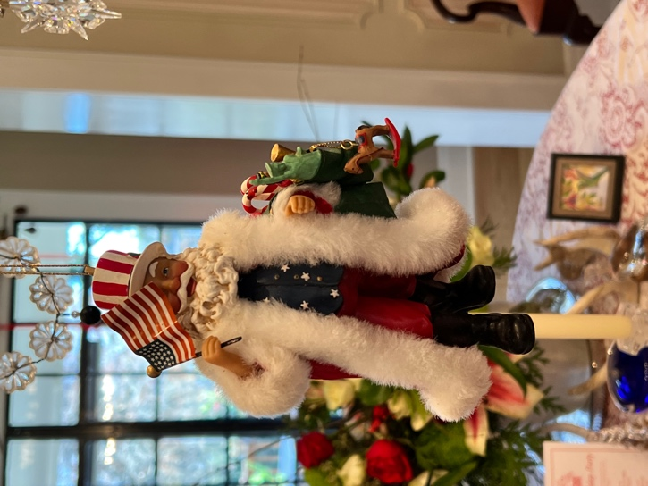
Photo: Festive decoartions with a patriotic twist. Pianist playing carols.
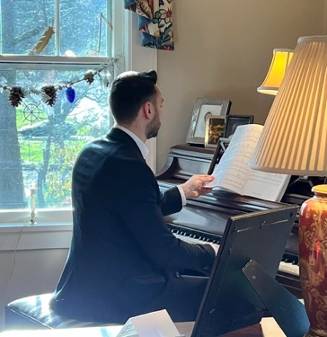

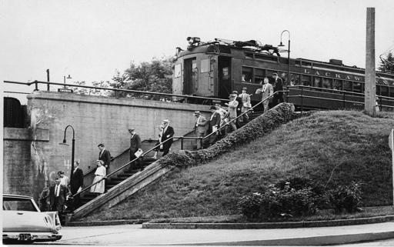
Photo: Liberty Hall Museum collection

JANUARY PROGRAM
Stitches in Time: Three Centuries of Hemlines, Necklines and Everything in Between
by Lynn Magrane

Please join us on Sunday, January 22 at 3:00pm in the Lundt Room at the Library of the Chathams for a fascinating look at the telling of history through fashion. An online option will be available for those who prefer. Members will receive an email with the details. Liberty Hall Museum in Union is the ancestral home of the distinguished Livingston and Kean families of New Jersey. Over the years their descendants have lovingly preserved and packed away the previous generation’s belongings in attics, basements, closets, drawers and even underneath the floor boards! Combined, they tell the story of a way of life that has vanished from the Garden State. This fashionable presentation covers all of the dos and don’ts and how fashion has changed over three centuries.

SAVING THE PAST FOR THE FUTURE- Archive Upgrades to Help Future Researchers
by Susan Allen and Marianne Ivers

The Chatham Historical Society (CHS) has a sizable collection of artifacts, including historical photos and documents. Since the CHS obtained a grant from the Caucus Archival Projects Evaluation Service (CAPES) in 2007, the focus has been to follow the prioritized steps from the CAPES archivist. A 23-page CAPES document gave the society guidance on how to prioritize organizing the collection. “Having this document gave us direction when, at the beginning, we didn’t know what to do first,” Curator, Susan Allen said.
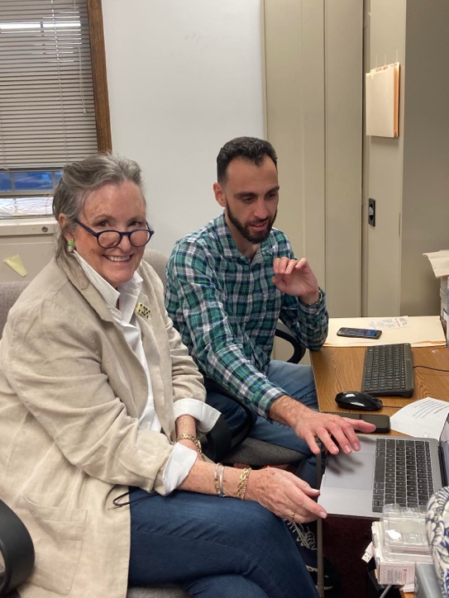
Photo: Susan Allen and Ben DiBiase

The current focus is the documentation of historic papers found in 20+ file drawers. The CHS board and society members are currently working on this project. The next step is entering the data into a cloud database in order to simplify the search for answers to the questions coming from genealogists, documentarians and subject researchers.

In February 2021, Ben DiBiase reached out to the CHS and offered to volunteer. He had recently moved to Chatham from Florida where he was employed as an Archivist for the Florida Historical Society. In Florida, he oversaw volunteers and other archivists with the labeling, organizing and submission of historic artifacts from local organizations in the Florida History database. With Ben’s insight he has helped keep the focus on the end goal. The CHS is now contemplating an internship program, the process of which Ben is familiar with.
“Currently our ability to respond to a question in a timely fashion is limited with only having a general idea of where to search for answers.” A recent inquirer was looking for the burial location of Revolutionary War soldiers that died of smallpox and were “buried in Chatham.” A reference book described a campground and an orchard where some individuals were believed to be interred. A letter received containing information about Giralda Farms led to a 2016 article from the Chatham Press of an archeological dig carried out there. Revolutionary War period artifacts were discovered at the site. Her search is not over, but the CHS was able to point the researcher to the possible location.

The new organized system, once completed, will significantly simplify
the process of aiding any researchers in their quests.

Recently, the CHS received a grant from the Morris County Heritage
Commission to help cover the cost for upgrading its database storage system.
Anyone interested in helping the CHS reach its goal of organizing its database, please reach out to the society through the website: https://www.chathamnjhistoricalsociety.org/
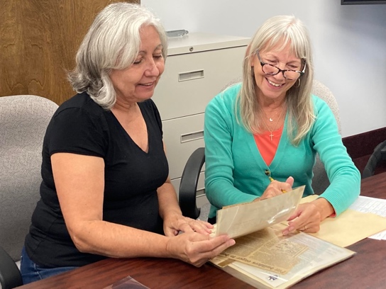
Photo: Deb Fabian and Lynn Magrane

THE PUPPETERS OF MINTON AVENUE
by Liz Holler
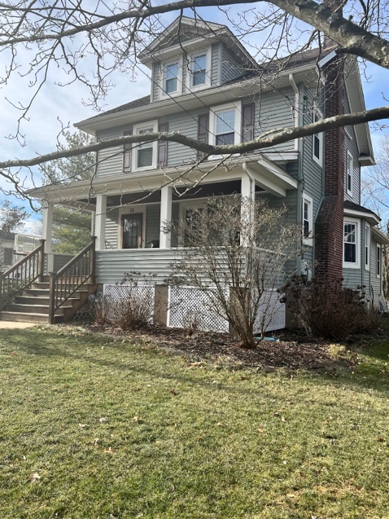
Photo: Current photo of 12 Minton Avenue
He was a slender, small gentleman, living on Minton Avenue, when I met Saki Fulton in the late 1970s through my friend, Evelyn Short, another resident on Minton.
Quiet and soft-spoken, Saki never told Evelyn and me much about his younger days or about his late close friend and business manager, Bobby Fulton, whose last name Saki had adopted years ago.
Evelyn and I didn’t know, when we sat on the front porch of 12 Minton Avenue, that the porch had once been the scene of entertainment for both adults and children. Bobby and Saki Fulton were both expert marionette puppeteers, presenting shows with their own carefully created puppets and scenery they had manufactured in the small barn behind 12 Minton Ave.
Born in Formosa in 1900, Saki came to the United States in 1920 and became a serious student of dance. With the help of his manager, Bobby Fulton, Saki made a number of successful appearances in New York, performing such acts as “The Sword Dance”, “The Geisha”, “The Lotus Flower” and “Rainbow of India”. All of Saki’s dances and costumes were his own creations. Over the years, he also painted incredible art work, some of which was displayed at the Chatham Library.
In 1934, at a porch reading at 12 Minton Ave., Saki read aloud a poem to his audience in Japanese, giving them a flavor of his exotic heritage. In his home, were a display of his carefully created marionettes. One of the favorite puppets were “The “Roxettes”, a group of ballet dancers who came to life by Saki’s one hand control.
Bobby Fulton, born in Geneva NY, started creating his marionettes in a corner of the Wolfe Building in downtown Chatham. A fellow puppeteer, Major Dawley, had kindly offered him some work space. Bobby Fulton put on puppet shows for birthday parties, PTA gatherings, and college groups, with Saki’s help.
Bobby Fulton’s passing in the 1940s was a sad blow for Saki. World War II broke out. Being Japanese, Saki went into hiding for a very long stretch. Neighbors told me that he stayed in the barn behind 12 Minton Ave., once a workshop for the Fulton puppets. A friend, Joe Callahan, brought Saki food and kept his spirits up, never revealing Saki’s whereabouts. At the war’s end, Saki returned to the main house and could move freely around town again. In his later years, he worked at the Springbrook Country Club.
On May 18, 1983, Saki passed away at Morristown Memorial Hospital. A Mass of the Resurrection was held for Saki at St. Patrick’s Church, Chatham. Saki’s ashes were sent to his sister in Japan. A special light, a special artist, was now gone from Chatham.

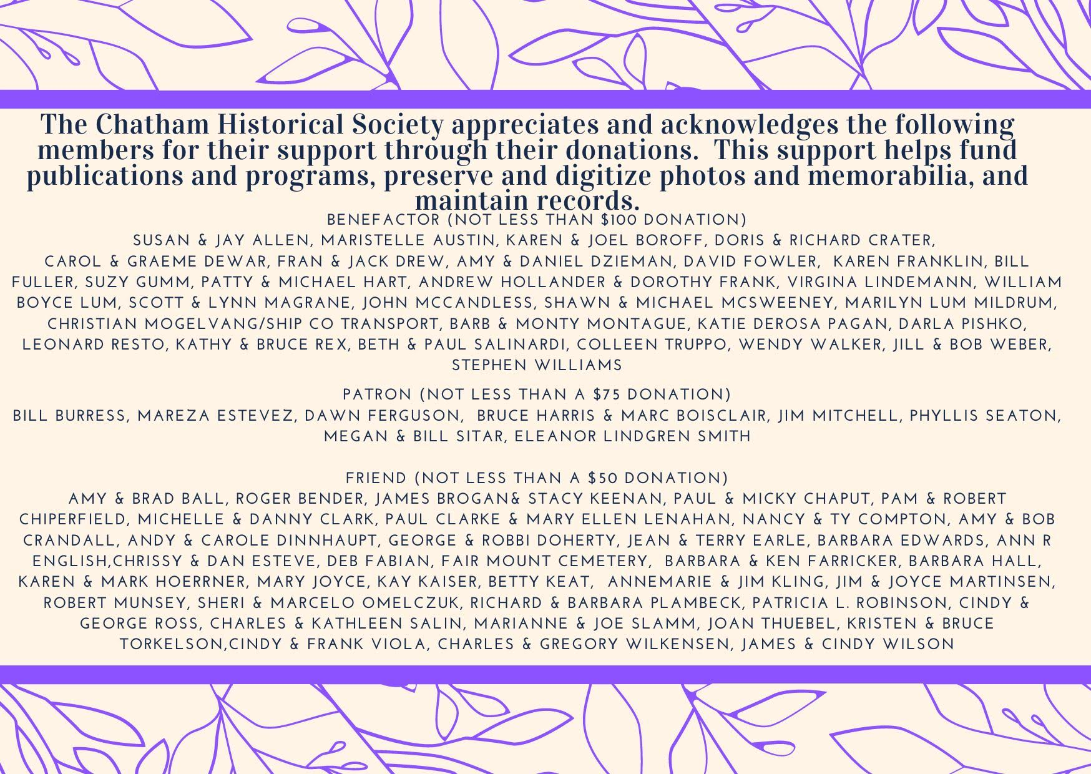

Please check our website frequently for up-to-date information about our programs and activities.
ChathamNJhistoricalSociety.org

Contact us via email
chathamnjhistory@gmail.com
Follow Us

@historychathamnj

Chatham Historical Society
Officers

Co-Leadership:
Debbie Fabian
Karen Hoerrner
Vice President:
Amy Crandall
Treasurer:
Christine Grobert
Secretary:
Stacey Keenan

